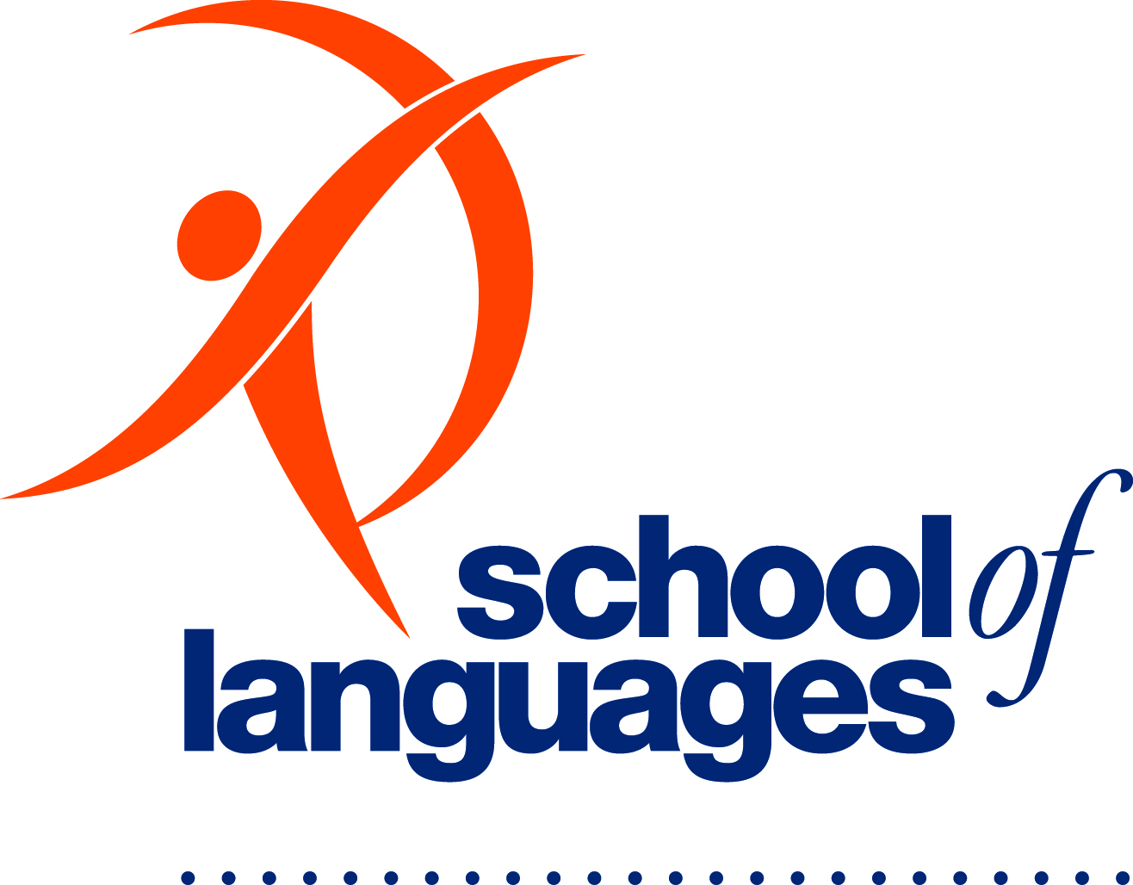 Volunteer application form: confidential

Thank you for considering becoming a volunteer for the Department for Education.
Please complete and return this form to the School of Languages.
Are you a parent/guardian of a child at the School of Languages? No Yes

Given and Family Name of your child: _________________________________________________
- If you are a parent or guardian of the child, in whose class you will be volunteering, you do not require a Working with Children Check (WWCC).

- If you are a family member (ie aunt, uncle, grandparent) or not related to a School of Languages’ student, then you require a WWCC. Please go to: https://screening.sa.gov.au/

- All volunteers must complete Responding to Abuse and Neglect training. (The https://www.plink.sa.edu.au/pages/signup.jsf takes about 90 minutes and includes an assessment.)
I would like to work as a volunteer in the _________________________ (language) class

at _____________________________ (teaching centre)

with ___________________________ (teacher).

Your personal details
Given name: |  | Preferred name for name badge:
Family name:
Home address: |  | Date of birth:
 |  | Female / male / other/not disclosed
Postal address:  Same as above |  | Home phone:
 |  | Mobile:
Email address:
Emergency contact name: |  | Emergency contact phone:
Do you have any psychological or medical conditions that might affect your ability to volunteer? Or anything we need to know in case of an emergency?
For example: diabetes, severe food allergy, asthma, epilepsy Yes No
(If yes please give details below and discuss at your interview.)

Do you need any assistance because of a disability? Yes No
(If yes please give details below and discuss at your interview.)

Are you vaccinated against Covid 19? Yes No

Please attach proof of your Covid 19 vaccination to this application form.

Your volunteering, employment or study details
Tell us about something you’ve done recently

Name of organisation:
Organisation phone:

How can you connect with our community?
Your country of birth:
Are you of Aboriginal and/or Torres Strait Islander origin? | Yes No Not stated
Languages you speak other than English:
Availability:
What days and times do you think you could volunteer?
Tell us about yourself:
List a few things that you can contribute to your role as a volunteer. For example, mentoring, gardening, storytelling, administration, sport
and so on.

Screening
Volunteering with us might mean that you need a working with children check.  You understand that if a working with children check is needed you will not be able to start volunteering until a clearance has been received.  If you have a working with children check already, please provide us with your screening reference number: _______________________________ | Yes No

Your personal referees
We will contact these people to find out a bit more about you. It’s okay if it’s someone at our school or centre who already knows you. We just need at least one person’s details.

Referee 1
Name: | Email or phone:
How do you know this person?
friend relative employer volunteer coordinator other (please specify):

Referee 2
Name: | Email or phone:
How do you know this person?
friend relative employer volunteer coordinator other (please specify):

Volunteer declaration – confidential
To make sure we meet our commitment to child safety, we need this information and declaration from you.
If you have any questions about this declaration, please talk to the education or early childhood service leader.

Have you ever been investigated or found guilty of any criminal offence, including any traffic offences not resolved by expiation? | Yes No
Have you ever been dismissed or resigned from any employment or a volunteer role in response to or following allegations of improper conduct relating to children? | Yes No
Have you ever been the subject of allegations or an investigation or any other process relating to alleged misconduct by you as a volunteer or an employee? | Yes No
Have you ever been the subject of allegations of inappropriate conduct of a violent or sexual nature towards or in relation to anyone? | Yes No
Have you ever been refused a child-related employment screening or working with children check in South Australia or in another Australian jurisdiction? | Yes No
Are you a prohibited person, as identified in the Child Safety (Prohibited Persons) Act 2016? | Yes No
Note: If you answered ‘yes’ to any of the above questions, you might be asked for more details, including any relevant documentation, before you can be placed as a volunteer.
You understand that if the information in this application or declaration changes, it is your responsibility to advise the education and early childhood service leader as soon as possible. | Yes No
I confirm and declare that to the best of my knowledge I have truthfully answered all questions. I understand that if I provide any false or misleading information I cannot start or stay on as a volunteer.
Your signature: Date: day/month/year)
Please give this completed form and declaration to the centre, preschool or school you want to volunteer at. They might contact you and organise a time for an interview or a chat.
The information you provide will be treated sensitively and confidentiality according to the State Records Act 1997 and the Information Privacy Principles Instruction.
OFFICE USE ONLY: Site leader: Proof of ID sighted File created, stored securely and confidentially

