Term 3 2022

Dear Students and Parents/Caregivers,

As Term 4 begins, we are embarking upon the process of re-enrolling students for 2023.

We hope that you intend to continue studying with us in 2023 and we will automatically re-enrol you for the next year level, unless you advise us otherwise.

If you decide not to study with us in 2023 please let us know by FRIDAY 18 NOVEMBER (WEEK 5) and we will cancel your 2023 enrolment. You can either
- Return the reply slip below to the school or
- Email the school at dl.1802.admin@schools.sa.edu.au or
- Telephone the school on 8301 4800

If you do decide to continue studying with us next year, you do not need to inform us. Please advise us if there will be any changes with respect to your personal details, for example, change in phone number, address details, day school (in particular Year 6 students going into high school), teaching centre, etc.

Enclosed with this letter is a copy of the 2023 Timetable, which you can refer to for teaching sites and lesson times.

A confirmation package will be given out in class in Term 4 Week 7.

NOTE: If you will be attending a day school, where you will be studying the language you study at the School of Languages, you must have a letter of approval signed by your day school Principal to continue your language studies with us.

All classes in 2023 commence in the week beginning Monday, 6 February 2023. (Term 1 Week 2, 2023)

Please do not make any payment until you receive an invoice in 2023.

In the event of the cancellation of a class due to insufficient numbers, we will contact you. If you do not hear from us we will expect to see you at the first lesson.

If you have any questions regarding the re-enrolment process for 2023 please do not hesitate to contact the Front Office on 8301 4800, or check our web site for further information. Thank you for your assistance.

Yours sincerely
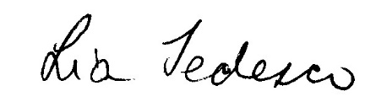
Lia Tedesco
Principal
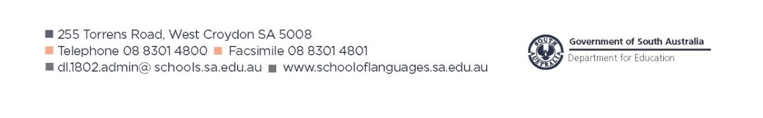
PLEASE USE BLOCK LETTERS

My child, ………………………………………….…………………………., will not be studying at the School of Languages in 2023.

Parent/caregiver’s signature:……………………………………………………………………… Date: ……………………………

