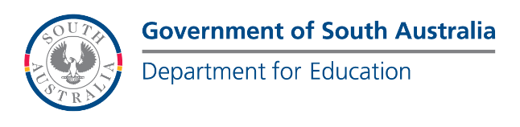
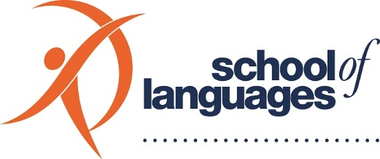

2023 school OF languages poster competition
We are delighted to invite R-12 students enrolled with the School of Languages to show their appreciation for languages and cultures by using their creative and artistic skills to design a poster around the theme:
DISCOVER YOURSELF, DISCOVER THE WORLD!

COMPETITION GUIDELINES

- Who is eligible?
The competition is open to all R-12 students enrolled at the School of Languages. The entrants will be categorised according to four groups:
Category A: Junior Primary (R-3 students)
Category B: Primary (Years 4-6)
Category C: Middle Years (Years 7-9)
Category D: Senior Secondary (Years 10-12)

- What do you have to do to enter?
Design a poster (hand-drawn/electronically) that reflects this year’s theme; Discover Yourself, Discover the World!

Hand-drawn poster entries
The title Discover Yourself, Discover the World!
- Must be included bilingually on the poster.
- Each poster must be the original work of the student; no group entries will be accepted.
- All posters must be the student’s original, creative artwork, including illustrations and images.
- Posters should be no larger than A2 size.

Electronic entries
In addition to points 1-3 above, any programs used for the design elements of an e-entry must be declared on the Competition Entry and Declaration form (see attached).

Helpful hints
Bold colours, clear artwork, and easy-to-read messages are best. Any additional text on the poster, (apart from the 2023 theme, Discover Yourself, Discover the World! written bilingually) must be in the language you are learning. Some thought starters for your design:
  - How has learning a language opened you up to new:
    - thoughts
    - feelings
    - possibilities
  - How has learning a language helped you to connect with other people?
Get creative! Use humour! Be playful! Find a unique angle!

2023 school OF languages poster competition

- What are the prizes?
- All entrants will receive a Certificate of Participation.
- Two winning entries from each category will be selected.
- Winners from all categories will receive $100 prize money and a Certificate of Excellence.
- All competition winners will be acknowledged on our Website, Social Media platforms and at the 2023 Celebration of Achievement.

- Competition entry and declaration form
The winning posters must meet all the requirements in these Guidelines. Posters will be judged on the level of originality, visual impact, artistic merit and how creatively they’ve expressed and explored the theme: Discover Yourself, Discover the World!
Artwork must be an individual student’s original creation. Three-dimensional entries will not be accepted. Nothing may be glued, stapled or attached to the artwork in any way, except for the Student Entry and Declaration Form, which must be glued or fixed to the back of the poster to be eligible.
  - Art paper used must be made of flexible material so that it can be rolled up in a mailing tube. Please roll up with poster side facing outward. Do not fold the poster.
  - Selection of winners will be made by a judging panel with representatives from the School Council and the School of Languages student body.
  - Winners will be notified in writing by the end of August 2023.

- When does the competition start?
Competition entries are open from 12th June 2023 until 4th August 2023.

- How do you submit your entry?
Entries can be mailed, emailed, or personally dropped off at the School of Languages reception area by 5pm on the 4th August 2023. Late entries will not be eligible.

- What are the conditions of the competition?
Entrants agree to be bound by the competition guidelines and the decisions of the School of Languages judging panel. They also accept all responsibility for late, lost, misdirected or ineligible entries.

For further information on the 2023 Poster Competition, please contact:

Maribel Coffey  Ph: (08) 8301 4800  Email: Maribel.Coffey885@schools.sa.edu.au | Steve Milazzo  Ph: (08) 8301 4800  Email: Steve.Milazzo522@schools.sa.edu.au

